Go to github/ create a new repo/

Choose: add ReadMe

Choose: add .gitignore: choose Node from down arrow list

Choose License: MIT License

Go to local machine/ open VSCode

From menu/ open folder / open LearnMicroservices folder

On the bottom terminal, type git clone..



Reopen a folder: Microservices_JobCategory_Job

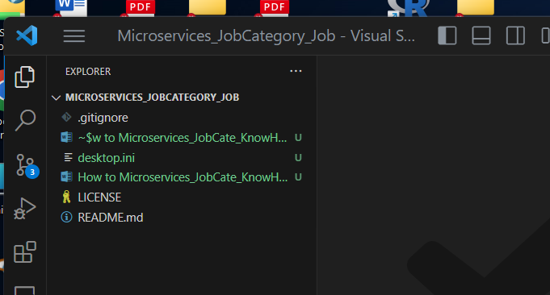

Create folder: server

Server > JobCategory

Server > Job

Add files into : server > JobCategory

Index.js

Add files into: server > Job

Index.js

The project tree as below”

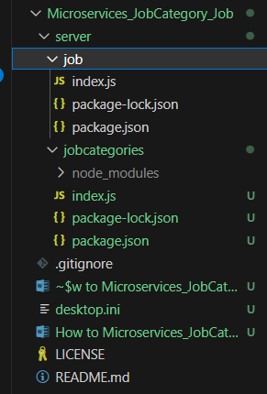

Add package.json

Go to terminal, server/ jobcategories/ : type: npm init -y



Package.json is created

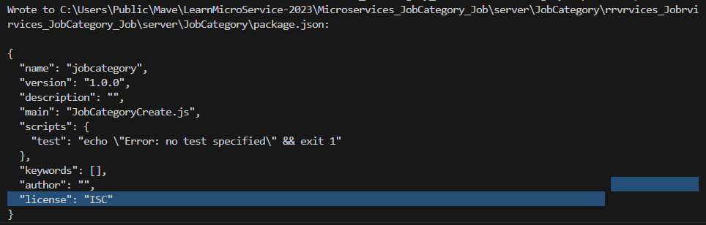

The project tree is as below:

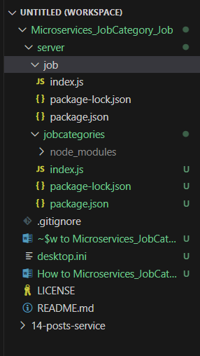

Continue install: npm install

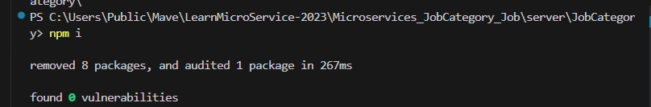

Install some others: npm install axios cors express nodemon



IMPORTMENT:

MUST npm i first, then, npm install axios cors express nodemon

Pop up below:

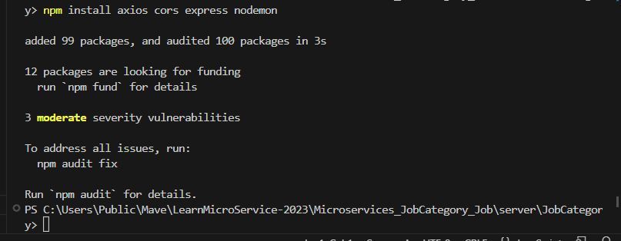

Go to package.json, change: “test:….” To “start: nodemon index.js”

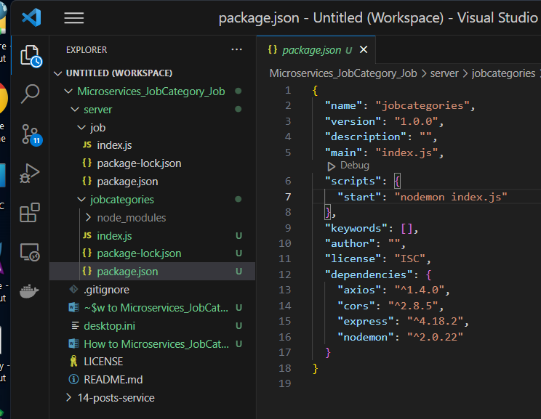

See the above: axios cors express nodemon have been installed.

Add index.js : server/ JobCategory / index.js

Go to terminal: go to server > JobCategory> npm start

Pop up the below:

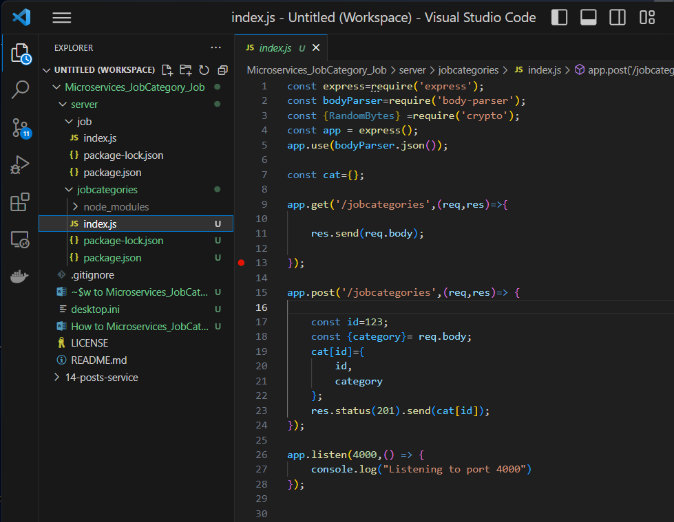

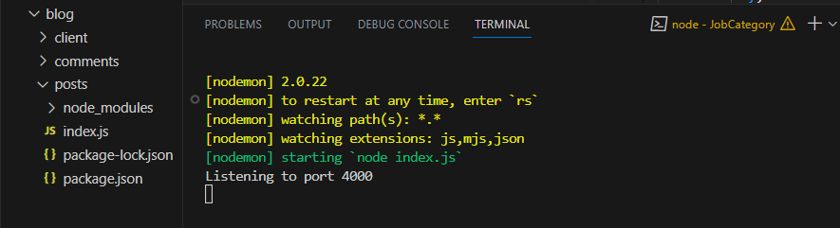

Test the JobCategory services: go to POSTMAN:

Choose the following tab on Postman:

Make change to : JobCategory> index.js

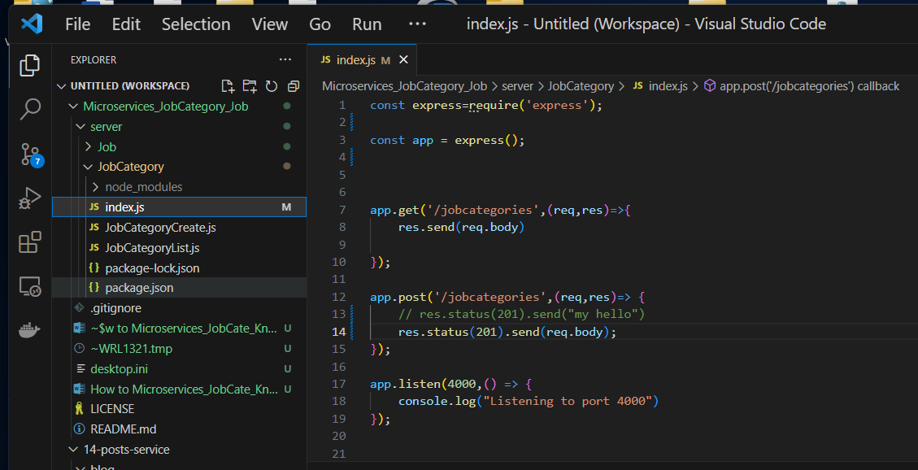

Go to Postman to test jobcategory service: jobcategory > index.js

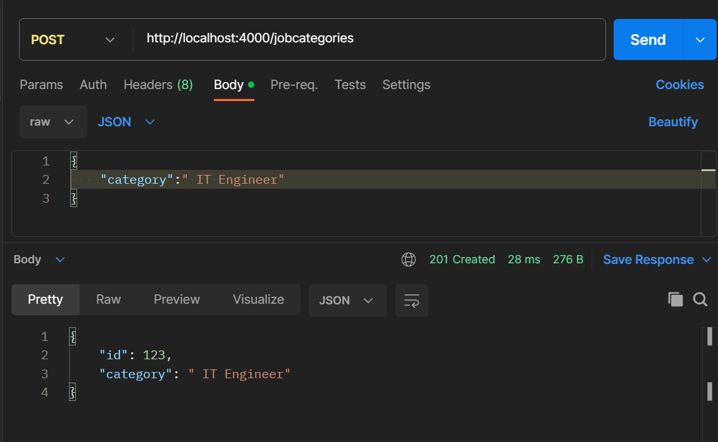

Nothing appeared. WRONG because: res.send(req.body) should be: res.send (req.body.category)

(IMPORTANT : below is the other version)

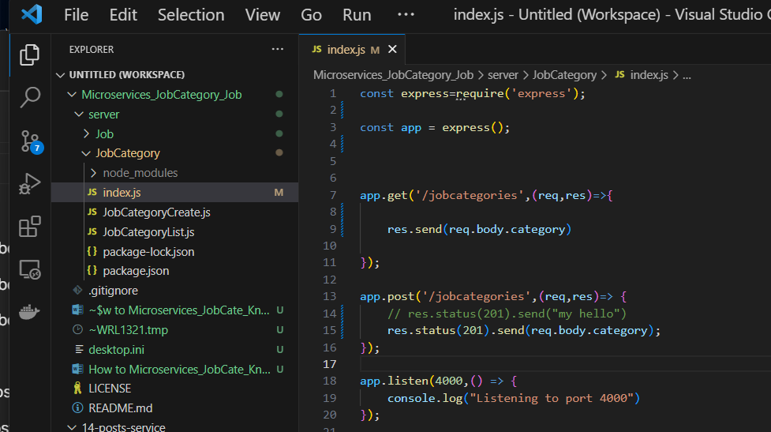

Add key to req.body: req.body.category,

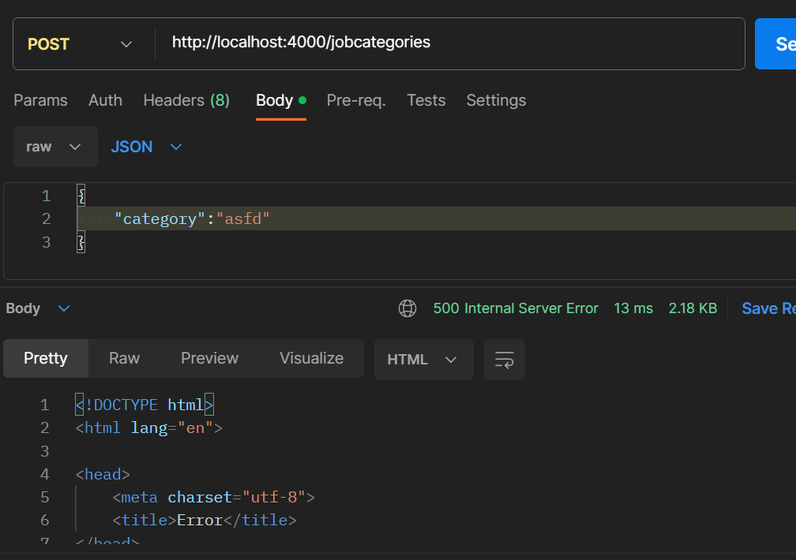

Add :

Const bodyParser = require(‘body-parser’);

app.use(bodyParser.json() );

But the above didn’t Work.

Because:

Req.body.category return a JSON object, can’t not do : res.send ( req.body.category);

CAN’T SEND AN OBJECT STRAIGHT FORWARD by http.RESPONSE

MUST RETRIEVE json object by its id.

Test in Postman

Make change to the jobcategory / index.js

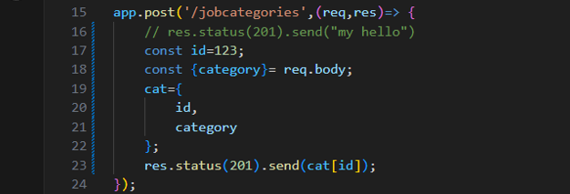

Assign req.body.category json object to a new JSON object

The above didn’t work!

Make another changes:

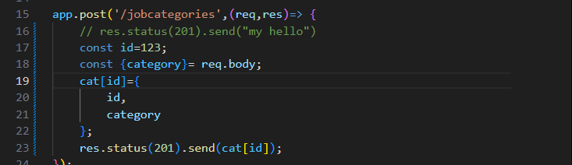

The above Worked!

Test it on Postman:

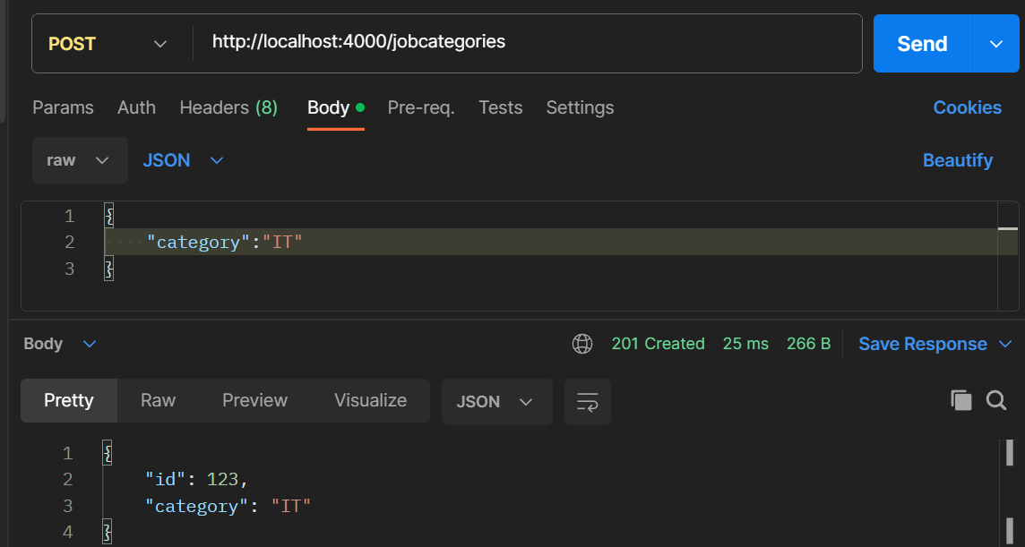

The new version of : server/ jobcategories/ index.js

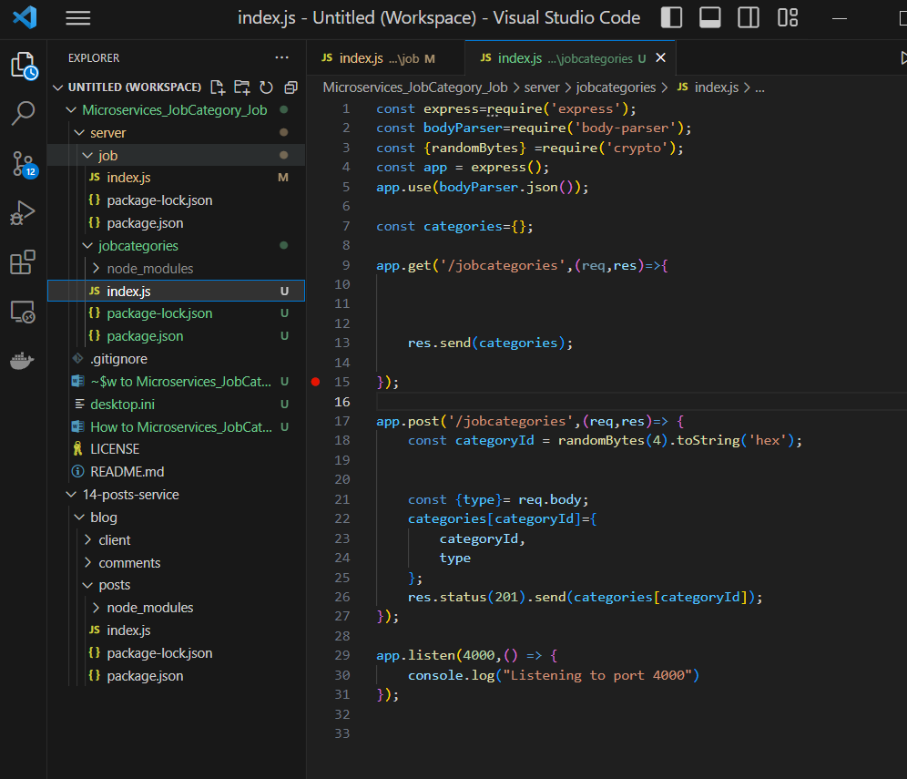

Test the above on Postman

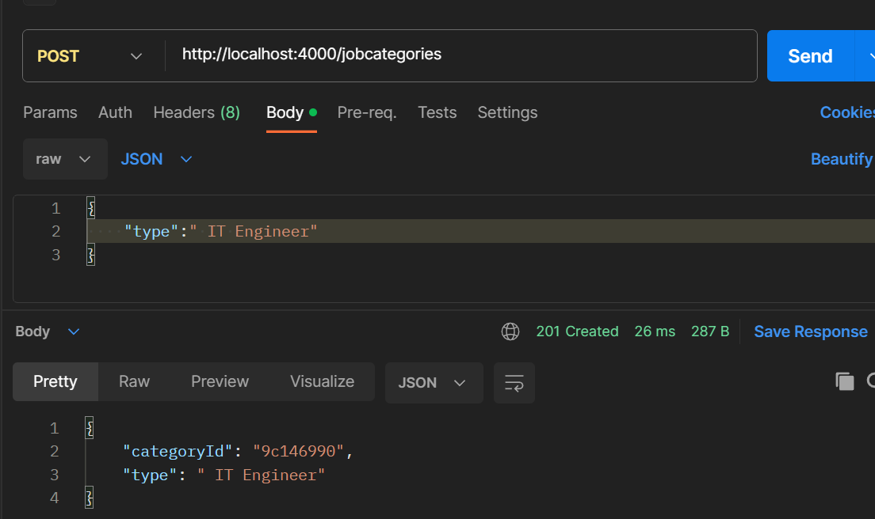

TEST GET ON Postman:

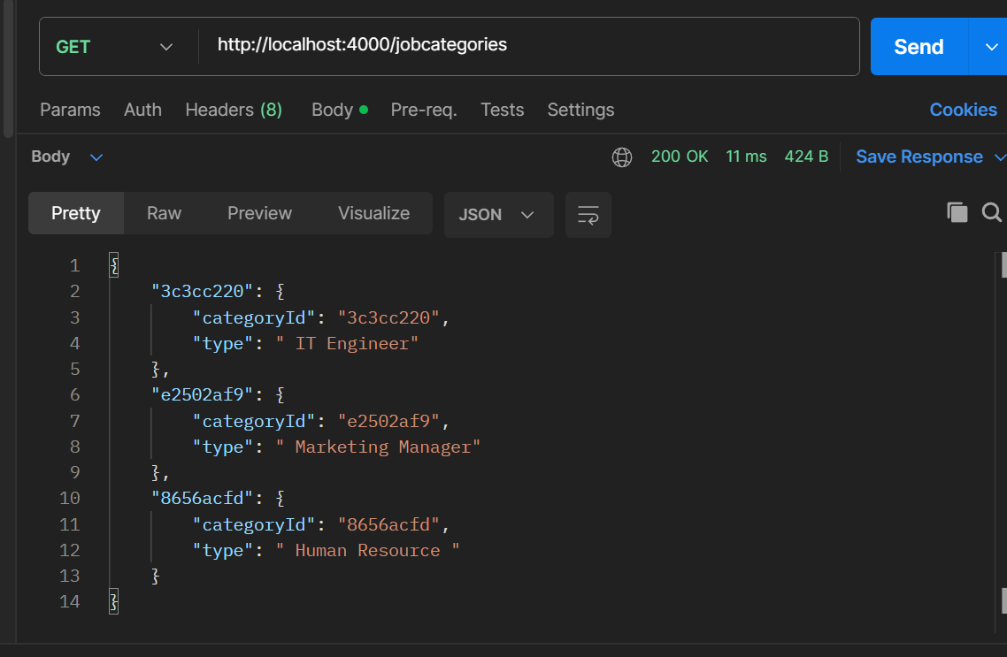

Create job: server/ job/ index.js